Madeira Roller Marathon

WORLD INLINE CUP Fact Sheet 2021

Dear team managers, dear athletes

Please find below the facts about this year’s “Madeira Roller Marathon WORLD INLINE CUP” on 13th june 2021. We wish you a successful race!

Facts about the Race

City: Funchal
Country: Portugal
Day: Sunday, 13th june 2021
Class: Class 1
Start/Finish: Avenida Sá Carneiro

Prize money: 5’000 EUR
Organizer: Alípio Silva / Juan Batista
Website: http://www.madeirarollermarathon.com/
https://www.facebook.com/MadeiraRollerMarathon/

Others events: Biosfera Roler Skate Internacional Tournment

Place: Faial, Santana
Country: Portugal
Day: Sunday, 11th and 12th September 2020

Prize money: 1’500 EUR
Organizer: Alípio Silva / Juan Batista
Website: http://www.biosfera-rollerskate.com/
https://www.facebook.com/BiosferaRollerSkate/

Technical Meeting

Technical Meeting: No specific WIC Technical Meeting this year (Class 1).
Only a General Technical Meeting, Sunday, 13th june at 10.00

Race Office: To recover active transponder/chip:
For athletes participating in Biosfera Roller Skate and Madeira Roller Marathon
On race office in Faial
Opening:on Friday, 11th june from 15:00 to 18:00

For athletes participating only in Madeira Roller Marathon
On race office in Avenida Sá Carneiro
Opening: on Sunday, 13th june from 07:30

Prize Money Distribution

PLACE | Women |  | Men
PLACE | WIC |  | WIC
1 | 1'000 € |  | 1'000 €
2 | 700 € |  | 700 €
3 | 300 € |  | 300 €
4 | 200 € |  | 200 €
5 | 150 € |  | 150 €
6 |  |  | 100 €
7 |  |  | 80 €
8 |  |  | 60 €
9 |  |  | 40 €
10 |  |  | 20 €

Race Schedule

Sunday, 13 june

09:00 100m sprint qualification
09:30 100m sprint ½ finals
09:45 100m sprint finals

10.15 School sports athletes
10:30 Nano-Marathon (800m) – U9 years
10:45 Micro-Marathon (2000m) – U11 years
11:10 Mini-Marathon (7000m) – U15 years

11:30 WIC Marathon - Start Men (Start Women - 1’ after) / 42 km / 17 laps

Award ceremony & prize giving just after the race
13.30 Closing Lunch on Cais 8 / Espetada Madeirense
For all WIC athletes and Team Managers/Coaches for free.
Invitation available on the village (race office)

Course map:
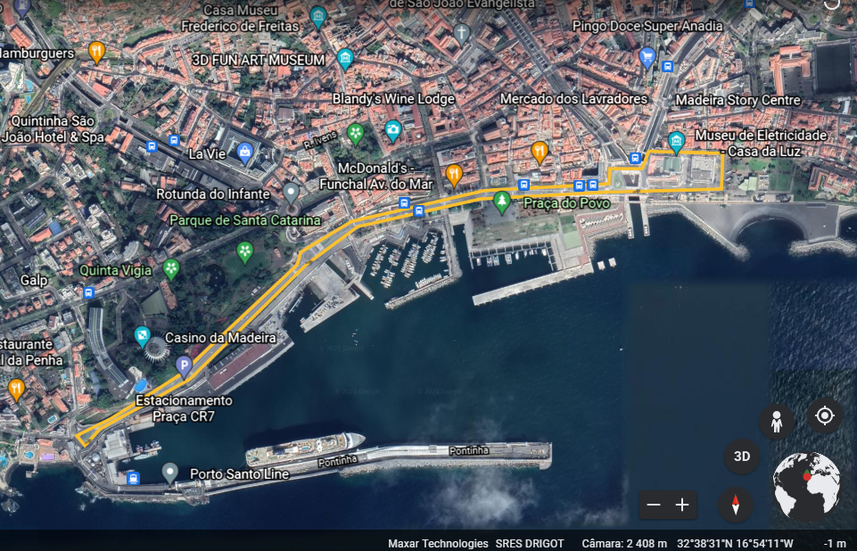
Distance of the lap: 3,3 km

Accommodation, Food and transport
The organization has several packs available to the skaters that include different services at very inviting prices.

In these packs we have different accommodations (local accommodation, youth hostels and hotels) food and shuttles.

Special Rates: more information: http://www.madeirarollermarathon.com/
The organization ensures transportation between the airport and hotel.

Organizer Contact

Organizer: CDR SANTANENSE
Contact Person: ALÍPIO SILVA
Mail: madeira.roller.marathon@gmail.com
Phone: +351 965267813
Web: http://www.madeirarollermarathon.com/
https://www.facebook.com/MadeiraRollerMarathon/

Visa
Please check yourself if you need a visa to enter the country.

COVID-19 Rules
• Athletes, coaches and companions from outside Madeira must respect the indications established in Resolution No. 484/2020 of the Regional Government of Madeira.
• Test on departure:
- Up to 72 hours before the flight;
• Test on arrival:
- arrival in the region must take place at least 24 hours before the race;
- Conduct, with the collection of biological samples on arrival, a PCR test to detect SARS-CoV-2;
- Remain in isolation, in the respective home or in the hotel establishment where he is staying, until the negative test result is obtained;

